Project Design Phase-II

Data Flow Diagram & User Stories

|  |  |
| --- | --- |
| Team ID | PNT2022TMID48844 |
| Project Name | Project - Smart Farmer -IOT Enabled Smart Farming Application |
| Maximum Marks | 4 Marks |

# Data Flow Diagrams:

A Data Flow Diagram (DFD) is a traditional visual representation of the information flows within a system. A neat and clear DFD can depict the right amount of the system requirement graphically. It shows how data enters and leaves the system, what changes the information, and where data is stored.

# Example: [(Simplified)](https://developer.ibm.com/patterns/visualize-unstructured-text/)

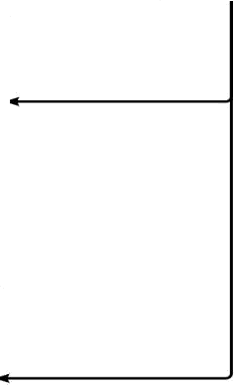

User

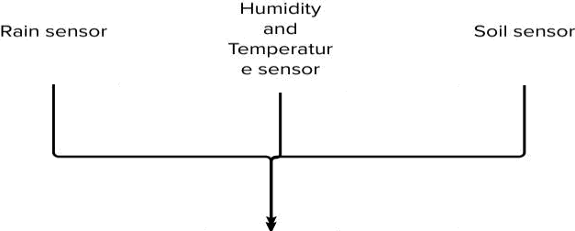

Water

Pump

Raspberry PI

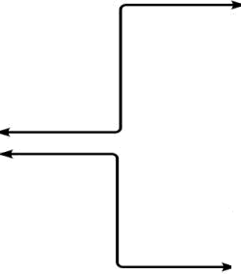

Wets ite

L'Jode Red

App

I BM Warson Platform

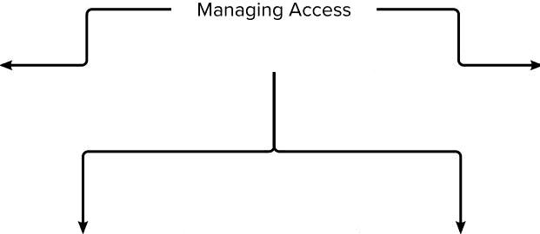

Enter Credential

Managing Sensors Value

Manage Crops Live Feed

Managing User Account

Manage Report



Invalid User Login

User Login

Enter into Module

# User Stories

Use the below template to list all the user stories for the product.

|  |  |  |  |  |  |  |
| --- | --- | --- | --- | --- | --- | --- |
| **User Type** | **Functional Requirement (Epic)** | **User Story Number** | **User Story / Task** | **Acceptance criteria** | **Priority** | **Release** |
| Customer (Mobile user) | Registration | USN-1 | As a user, I can register for the application by entering my email, password, and confirming my password. | I can access my account / dashboard | High | Sprint-1 |
|  |  | USN-2 | As a user, I will receive confirmation email once I have registered for the application | I can receive confirmation email & click confirm | High | Sprint-1 |
|  |  | USN-3 | As a user, I can register for the application through Face book | I can register & access the dashboard with Face book Login | Low | Sprint-2 |
|  |  | USN-4 | As a user, I can register for the application through email |  | Medium | Sprint-1 |
|  | Login | USN-5 | As a user, I can log into the application by entering email & password |  | High | Sprint-1 |
|  | Dashboard |  |  |  |  |  |
| Customer (Web user) |  |  |  |  |  |  |
| Customer Care Executive | Help | USN-1 | As a user, if I have any queries or issues. I can reach out to the support team. | I will receive a reply from the support team that my message is accepted and later my queries or issues  will be resolved | Medium | Sprint-3 |
| Administrator | Management | USN-1 | As a user if i didn't receive a quality product, I want a refund | I can receive a free service or a change of  product | Medium | Sprint - 4 |
|  |  |  |  |  |  |  |
|  |  |  |  |  |  |  |